LOB LOJ lobsters

In the southern areas of its distribution, western rock lobster mature at six to seven years old, at a carapace length of about 90 millimetres. In the northern waters near Kalbarri and at the Abrolhos Islands, they mature at smaller sizes, usually at about 70 millimetres carapace length, owing to the relatively warmer water. (<http://www.fish.wa.gov.au/Documents/recreational_fishing/fact_sheets/fact_sheet_western_rock_lobster.pdf>)

Their food contains a wide range of items such as coralline algae, detritus (dead and dying marine matter), molluscs and crustaceans.

Jo11 & Phillips (1984) examined the diets of rock lobsters at Seven Mile Beach and

Cliff Head, and discovered that the foregut contents of rock lobsters at Seven Mile

Beach were dominated by calcareous algae while those at Cliff Head were dominated

by molluscs.

The major food items consumed by P. Cygnus at Seven Mile Beach were epiphytic

coralline algae (almost exclusively ***Corullina cuvieti*** Larnour. and ***Metagonolithon***

***ste@&-um*** [(Lamarck) W, Bosse], molluscs and “worms”(polychaetes and sipunculans)

(Table II). Few rock lobsters had large quantities of both animal material and coralline

algae in their foreguts; rock lobsters predominantly ingested either animal material or

large quantities of coralline algae.

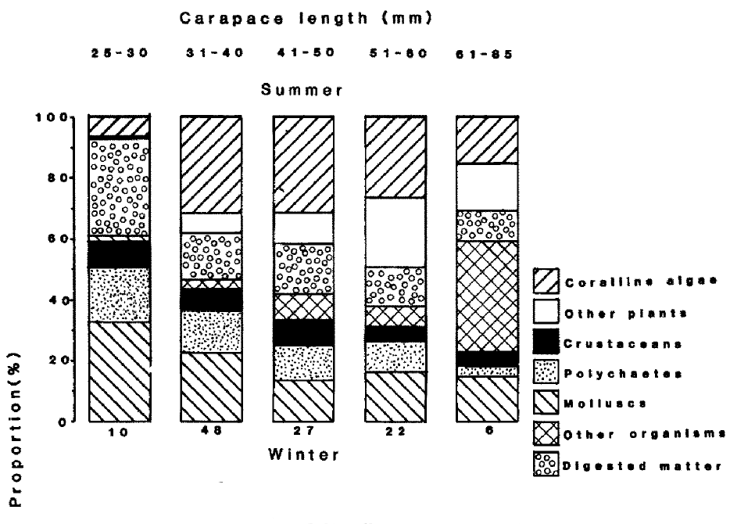

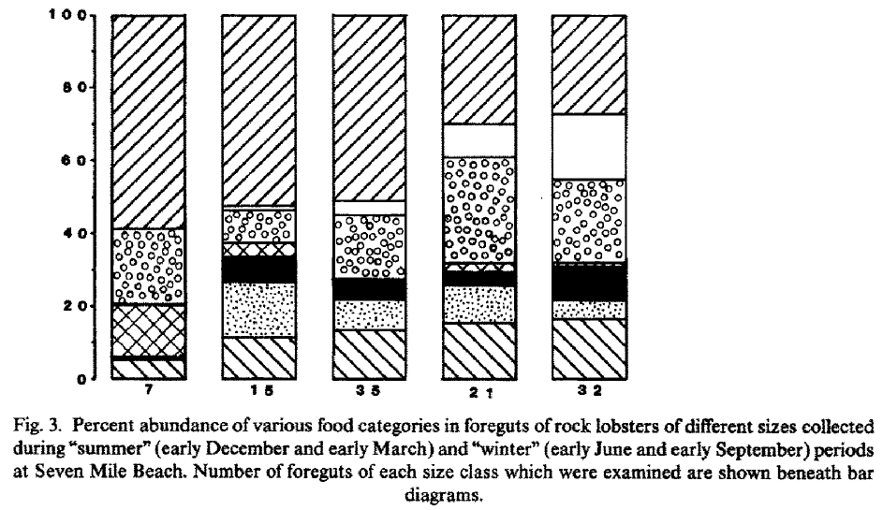

The gut contents of small rock lobsters differed appreciably from the contents of larger rock lobsters. This ontogenetic shift in diet was partly confounded by seasonal changes in the diets of small individuals (Fig. 3). During the summer months (December and March), the smallest size class of rock lobsters (25-30 mm carapace length) ingested considerable quantities of molluscs (33 p0 of total food consumed) but very little coralline algae (7% of total). Large rock lobsters ate more coralline algae and less molluscs than the smallest rock lobsters at this time. During the winter months this situation was reversed with the smallest size class of rock lobsters ingesting much more coralline algae (59% of total) and less molluscs (6% total) than large rock lobsters. Seasonal changes in the diets of rock lobsters > 50 mm carapace length were much less obvious than changes in the diets of smaller individuals. Large rock lobsters, for example, consumed considerable quantities of seagrass and the alga ***Cuulerpa cactoides*** throughout the year. The only obvious seasonal change in the diets of large rock lobsters was the occurrence of large quantities of fish and mammal hides in the guts of animals > 60 mm carapace length collected from the ***Halophila*** habitat in December. These rock lobsters were presumably ingesting baits discarded from a fishing boat moored within the study site.

The most striking feature of the diets of Cliff Head rock lobsters was the importance of the trochid mollusc *Cantharidus lepidus*(Table III). Because of the predominance of this mollusc in gut contents, *C.* ***lepidus*** has been included in Table III as a separate food category. A second trochid at Cliff Head, *Phasianotrochus irisodontes*(Quoy & Gaimard), was also consumed in large quantities.

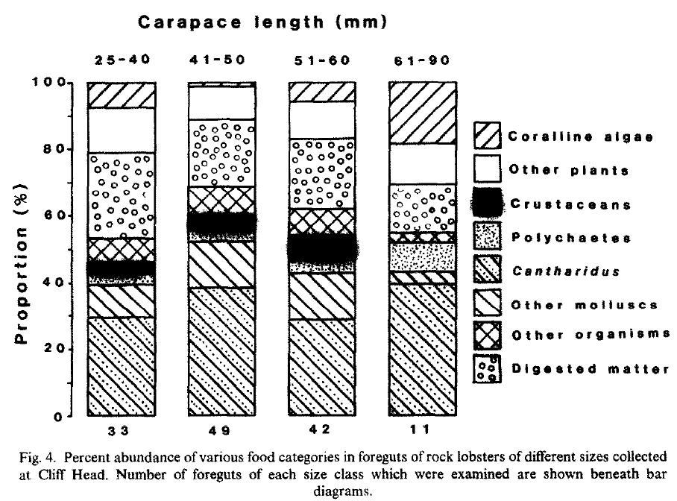

*Panuliruss cygnus* was highly size-selective as a predator, capturing very few gastropods

c 2.0 mm sieve size, even when molluscs below this size were extremely abundant. At

CEff Head, rock lobsters collected from both the *Arnpbolis* and *Haloophila* habitats

primarily consumed 2.8 and 4.0 mm sieve size *Canthatis* *lepidus,* despite major

differences in the size distributions of prey between habitats, and a predominance of

trochids < 2.8 mm in the field (Fig. 6). The sizes of ingested prey nevertheless shifted

slightly between March and June, reflecting the higher field densities of molluscs

>4.0 mm sieve size in June. The diet of ***P. Cygnus*** at the two Western Australian sites

encompassed this wide panulirid dietary spectrum. The documented differences in diet

between rock lobster species may therefore reflect local prey availability as much as real

interspecific differences. ***P. Cygnus can vary*** dietary intake by selectively capturing

benthic faunal species of high nutritive value, such as at Cliff Head during autumn, by

consuming vast amounts of relatively low calorific epiphytic algae, such as at Seven Mile

Beach in June, or by ingesting variable proportions of both plant and animal material.

The choice of foraging strategy by ***P. Cygnus*** appears to depend largely on the availability

of molluscs or other slow moving prey of a suitable size. The very large quantities of calcareous algae consumed by

***P. cygnus in*** the ***Amphibolis*** habitat in June 1985, futhermore, coincided with the lowest

recorded field densities of coralline algae as well as the time of negligible densities of

2.0-4.0 mm sieve size molluscs.

The diet of spiny lobsters can change with lobster size (Goni et al., 2001;Mayfield et al., 2001; Langlois et al., 2006b). Differences in choice of prey have been demonstrated for Jasus edwardsii, with larger lobsters tending to choose large prey and smaller lobsters tending to choose small prey (Langlois et al., 2006b). Previous studies have found that juvenile P. cygnus consume a wide range of benthic biota including molluscs, polychaetes, small crustaceans and coralline algae (Joll and Phillips, 1984; Edgar, 1990; Jernakoff et al., 1993). At all locations gut content analysis indicated that lobsters were omnivorous, preying on amphipods/isopods, crabs, bait, foliose red algae and sponges. One consistent pattern was that bait, crabs, and amphipods/isopods were likely to be important components of the diet at all locations. Bait was estimated to have contributed between 30 and 57% of the diet of lobsters at Lancelin, between 62 and 79% at Jurien Bay, and between 4 and 70% of diet of lobsters at Dongara. Crabs (Lancelin 0–50%; Jurien Bay 0–26%; Dongara 0–76%), and amphipods/isopods (Lancelin 0–54%; Jurien Bay 0–23%; Dongara 0–52%) were also likely to be important diets at all three locations. Foliose red algae (Lancelin 6–25%; Jurien Bay 2–13%; Dongara 0–13%) and sponges (Lancelin 0–16%; Jurien Bay 0–11%; Dongara 0–15%) were likely to be of lesser importance. IsoSource also estimated that lobsters at Dongara might also prey on molluscs (bivalves and/or gastropods: 0–24%). The composition of food items in lobster foreguts were dominated by crabs (61.8%); bait (13.9%) and amphipods/isopods (9.1%) were also important (Fig. 3). Bivalves/gastropods, foliose red algae, sponges, and polychaetes each comprised less than 2% of gut contents (Fig. 3).

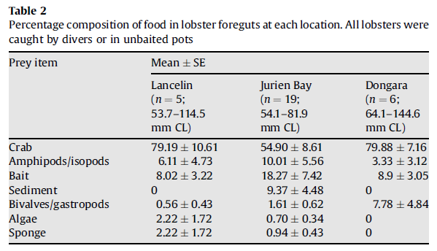

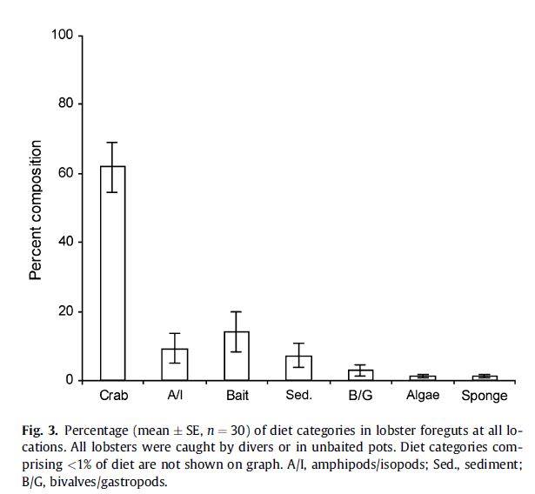

Grapsoid crabs of the genus *Plagusia (pelagic crab)* In total, 13 dietary items were found in the stomachs of the studied crabs Plant materials were found in the stomachs of 96.9% of the crabs examined, whereas animal and unidentified materials were found in 49.7% and 71.0% of the individuals, respectively, in terms of percentage of occurrence for all seasons, sizes and

sexes combined (Table 1). Rhodophyceae was the most common (91.8%) dietary item and were represented mainly by articulated coralline algae. Second most frequent plant material was Chlorophyceae (39.1%), consisting mostly of the ulvacean foliose algae. Among animal items, the highest occurrence was of Crustacea (38%), particularly of Amphipoda from the suborder Gammaridea (36.7%), and to a lesser extent Mollusca (13.7%) and Annelida (9%). Similar resultswere obtained in terms of average volume (points), as stomach contents were again dominated by plant materials such as articulated coralline algae (52.6 points; Rhodophyceae) and Ulvaceae (6.5 points; Chlorophyceae), but the importance of the latter was relatively less than in the percentage occurrence analysis. Among animal materials, the most important item was represented by small crustaceans such as Gammaridea (2.8 points) whereas other animal items represented even less volume of the stomach contents.

Larvae: The dataset from this study indicates that gelatinous zooplankton are significant in the trophic ecology of P. cygnus. This is entirely consistent with the hypothesised diet items that have been inferred from examining the mouthparts and feeding structures of phyllosomata [1]. Tunicates, fish larvae, siphonophores and chaetognaths have been indicated as prey in the DNA diet studies of P. japonicus [26,28,29] as well as in experimental feeding of P. interruptus [19]. The discovery of DNA from colonial radiolarians in the guts of phyllosomata is a new addition to the groups of organisms associated with the diet of phyllosomata.

|  |  |
| --- | --- |
| **prey item** | **probability of consuming** |
| bivalve BFF | 0.2 |
| gastropods BG | 0.3 |
| polychaetes BC | 0.1 |
| crabs MAZ | 0.2 |
| seagrass SGR | 0.1 |
| algae MA | 0.3 |
| detritus DC | 0.05 |
| ZME | 0.05 |

Reference

Graham J. Edgar 1990 Predator-prey interactions in seagrass beds. I. The influence of macrofaunal abundance and size-structure on the diet and growth of the western rock lobster *Panulirus cygnus*George ***J. Exp. Mar.*** Biol. ***Ecol.,*** 1990, Vol. 139, pp. l-22

Kris I. Waddington, Lynda M. Bellchambers, Mathew A. Vanderklift, Diana I. Walker 2008 Western rock lobsters (Panulirus cygnus) in Western Australian deep coastal ecosystems (35–60 m) are more carnivorous than those in shallow coastal ecosystems. Estuarine, Coastal and Shelf Science 79 114–120

Stepanus A Samson, Masashi Yokota, Carlos A Strüssmann and Seiichi Watanabe. 2007. Natural diet of grapsoid crab *Plagusia dentipes* de Haan (Decapoda: Brachyura: Plagusiidae) in Tateyama Bay, Japan Fisheries Science 2007; 73: 171–177

O’Rorke R, Lavery S, Chow S, Takeyama H, Tsai P, et al. (2012) Determining the Diet of Larvae of Western Rock Lobster (Panulirus cygnus) Using High-Throughput DNA Sequencing Techniques. PLoS ONE 7(8): e42757. doi:10.1371/journal.pone.0042757